**A PROJECT REPORT ON**

**GSM BASED REMOTE MONITORING AND BILLING**

**SUBMITED BY**

**AWESOME**

**Aditya M Anand (NEC0912001)**

**Athun VM (NEC0912016)**

**Gayathri M (NEC0912027)**

**Jeevanandam (NEC0912031)**

**Jishnunand PK (NEC0912032)**

**Manoj S Mali (NEC0912037)**

**JUNE 2015**

**Submitted in the particular fulfillment of requirements for the award of Diploma in Information Technology**

**NETTUR TECHNICAL TRAINING FOUNDATION**

**#40/40 A, IT BLOCK, Electronic City,**

**Hosur Road**

**Bangalore - 560100**

**NETTUR TECHNICAL TRAINING FOUNDATION**

**#40/40 A, IT BLOCK, Electronic City,**

**Hosur Road**

**Bangalore – 560100**

**CERTIFICATE**

**This to certify that the project work titled “SOUTHERN POWER DISTRIBUTION COMPANY” Has been successfully completed in fulfillment of the award of Diploma in Information Technology Offered by NTTF during the academic year 2015**

**Project Guide Academic In charge Principal**

**Examiners**

**Name of the Examiners Signature with Date**

**SYNOPSIS**

**The idea of the developing the application is to provide support for the new post-paid meters, managed remotely by SMS base on GSM.**

**This application also provides a facility for the customers like online bill payment.**

**It is particularly applicable for developing and underdeveloped countries where such a post-payment solution may be desirable.**

**It can solve all the standard business problems existing in operation and maintenance of utilities that use a post payment system.**

**ACKNOWLEDGEMENT**

We express our sincere gratitude to **Mrs.Prabha, Mr.Sreedhar** our project in charge for providing us with such a great facility and good staff to improve our skills. The intensive training to us useful and we learnt most of the IDE’S.

We are grate full to **Mrs.Chitra** **Devi** and **Mr.Jagadish** for their unwavering support and active cooperation throughout the project work.

Finally a round of thanks to the team of NTTF IT CENTER, the teaching and non-teaching staff for their help extended to us. Last but not the least we would acknowledge and abundant help received from our friends in successful completion of our project

**CONTENTS**

1. **Introduction**

* 1. Title Of The Project
  2. Group Name
  3. Group Leader
  4. Group Members
  5. S/W & H/W Configuration
  6. Technology Used
  7. Project Description
  8. Project Modules
  9. Project Plan

1. **SRS Document**
2. **System Design**
   1. Controll flow diagram
   2. Data Flow Diagram
   3. Entity Relationship Diagram
   4. Use case Diagram
   5. Database Design
   6. Data Dictionary
   7. Gantt chart
3. **Snapshots**
4. **Source Code**
5. **Reports**
   1. Test Plan
   2. Test Case
   3. Bug Report
6. **Future enhancement of project**
7. **Bibliography**
8. **Conclusion**
   1. TITLE OF THE PROJECT

SOUTHERN POWER DISTRIBUTION COMPANY………………….

* 1. GROUP NAME

AWESOME…………..

* 1. GROUP LEADER

Aditya M Anand -(NEC0912001)

* 1. GROUP MEMBERS

Athun VM (NEC0912016)

Gayathri M (NEC0912027)

Jeevanandam (NEC0912031)

Jishnunand PK (NEC0912032)

Manoj S Mali (NEC0912037)

* 1. S/W & H/W CONFIGURAION

SOFWARE REQUIREMENT

Programming language 🡪 j2ee

Frame Work 🡪 Hibernate3.0,Structs2

Web Technologies 🡪 JSP, HTML, CSS,CSS3

Database 🡪 Oracle10g

Scripting language 🡪 Java script

Web Server 🡪 Apache Tomcat Server6.0

Operating System 🡪 Windows 7 and higher version

IDE 🡪 Eclipse with my Eclipse plug ins

Text editor 🡪 Sublime text3

Browsers 🡪 IE8/8+, Chrome15+, Safari 4+, Mozilla Firefox

HARDWARE REQUIREMENT

Processor : Pentium IV

Hard disk : 80GB

Ram : 512MB

* 1. PROJECT DESCRIPTION

The objective of this project is to replace the existing manual reading of electricity meters installed throughout the country (Home, Agricultural, and Industrial).

The proposed solution is to build a server for the Electricity boards in each state where the custom built GSM meters would update in real time through SMS.

* 1. PROJECT MODULES

Admin

User

* 1. PROJECT PLAN

Requirement Analysis

Design and Coding

Testing

1. SOFTWARE REQUIREMENT SPECIFICATION

3.1 CFD

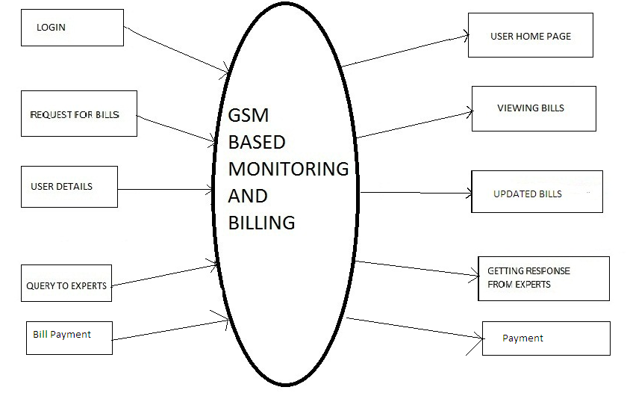USER FUNCTIONALITY

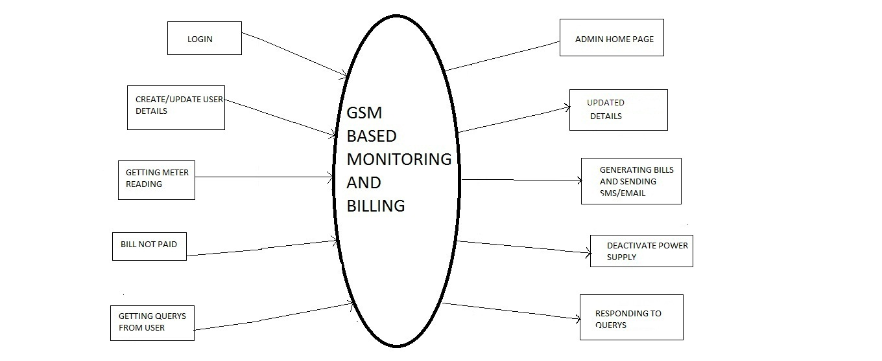ADMIN FUNCTIONALITY

ADMFUNCTIONALITY

3.2 DFD

